Midweek Sermon Series: King’s Arrival
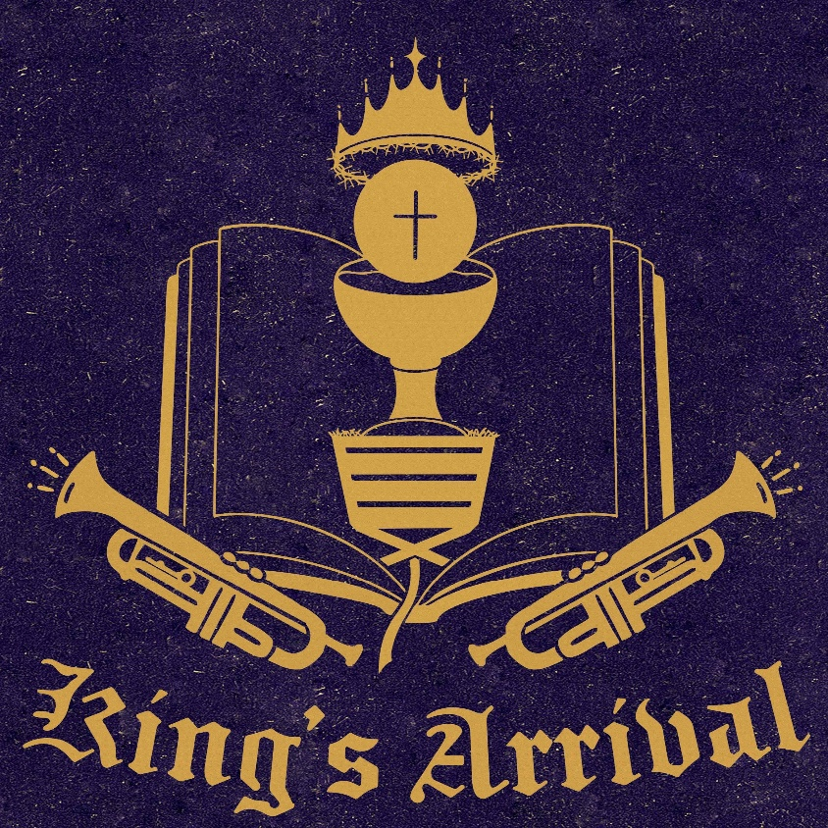

WEEK 1: Anticipation – Preparing for the King
Main Text: Isaiah 40:1–11
Additional Texts: Psalm 24:7–10; Malachi 3:1–4; Luke 1:5–25
Main Points
- The Longing for Comfort (Isaiah 40:1–2)
- The Voice in the Wilderness (Isaiah 40:3–5)
- The Glory of the King Revealed (Isaiah 40:9–11)
Application
- Advent begins in holy longing. We look around our weary world and cry, “Come, Lord Jesus!”
- Advent calls us to readiness, not fear; to joyful anticipation of the One who brings both power and peace.
“Like families counting down to a new child’s arrival, we count the days of Advent in holy expectation—because this King truly comes, and His arrival changes everything.”
Monday – Isaiah 40:1–5
Challenge: Where do you need God’s comfort this week? Ask Him to prepare your heart for His peace.
Tuesday – Psalm 24:7–10
Challenge: What “gates” in your life—habits, priorities, attitudes—need to be lifted to welcome Christ?
Wednesday – Malachi 3:1–4
Challenge: How can repentance refine your heart like silver to receive the Lord’s coming?
Thursday – Luke 1:5–17
Challenge: Who in your life might need to hear a word of preparation and hope this Advent?
Friday – Philippians 4:4–5
Challenge: How does knowing Christ is near change your response to stress or hurry?
Saturday – Romans 13:11–12
Challenge: Name one spiritual practice—Scripture, prayer, service—you will commit to as preparation for the King.

WEEK 2: The King Who Will Come in Glory
Main Text: Revelation 22:12–13
Additional Texts: Matthew 25:31–32; Philippians 3:20–21; 1 Peter 1:13
Main Points
- The Promise of His Return (Revelation 22:12)
- The Justice of the King (Matthew 25:31–32)
- The Transformation of the Saints (Philippians 3:20–21)
Application
- Our hope rests not in politics, progress, or plans—but in the promise of the returning King.
- Live now as citizens of the coming Kingdom. Our daily repentance and faith are practice for eternity.
“Our anticipation spills over from Advent into every day. We await the King whose arrival will peel back the sky and reveal His total goodness forever.”
Monday – Matthew 24:42–44
Challenge: What would you do differently if you truly believed Christ could return today?
Tuesday – 1 Thessalonians 4:16–18
Challenge: How does this promise comfort you when you think of death or loss?
Wednesday – 2 Peter 3:10–13
Challenge: What parts of your life need to reflect the holiness of the “new heavens and new earth”?
Thursday – Matthew 25:31–34
Challenge: What does it mean to live now as one already welcomed into the King’s kingdom?
Friday – Philippians 3:20–21
Challenge: This week, let your words and actions reflect the values of heaven’s King.
Saturday – Revelation 22:20
Challenge: What area of your life most needs you to pray that simple, hopeful prayer today?

WEEK 3: The King Who Comes in Word and Sacrament
Main Text: John 14:18–23
Additional Texts: Matthew 28:20; 1 Corinthians 11:23–26; 2 Corinthians 4:6
Main Points
- The Promise of Presence (John 14:18–20)
- The Miracles in Commonplace Things (1 Corinthians 11:23–26)
- The Light That Shines in Our Hearts (2 Corinthians 4:6)
Application
- Christ’s Advent continues every Sunday as He keeps His word: “Lo, I am with you always.”
- Approach the font and altar with the same awe as Bethlehem’s shepherds; the same Savior meets us here.
- Every encounter with Word and Sacrament is a face-to-face meeting with the King who reigns even now.
“Our excitement is often muted at font and altar, yet here Jesus meets us face to face—just as truly as in Bethlehem, just as surely as when He comes on the clouds.”
Monday – John 1:14
Challenge: Begin your week by reading Scripture aloud—let Christ’s living Word dwell with you.
Tuesday – Matthew 28:20
Challenge: Where do you most need to remember Christ’s presence in your daily routine?
Wednesday – Acts 2:38–39
Challenge: Reflect on your baptism this week. How does it shape your identity and purpose?
Thursday – 1 Corinthians 11:23–26
Challenge: How do you approach the Lord’s Table—with routine or with reverent joy?
Friday – Luke 24:30–32
Challenge: Pray that Christ would make Himself known to you in familiar places and moments.
Saturday – 2 Corinthians 4:6–7
Challenge: How can you reflect the light of Christ’s presence to someone who feels forgotten?

WEEK 4: The King Who Came in Humility
Main Text: Luke 2:8–20
Additional Texts: Isaiah 9:6–7; Micah 5:2; John 1:14
Main Points
- A Night Like No Other (Luke 2:8–14)
- The Shepherds’ Response (Luke 2:15–17)
- The Word Made Flesh (John 1:14; Isaiah 9:6–7)
Application
- God’s glory often comes where we least expect it—hidden in humility.
- Faith that receives also proclaims. The good news of the King’s arrival is too wonderful to keep silent.
- The King’s humility is the shape of His kingdom—and the pattern for our lives.
“Great indeed is the mystery that drew the shepherds through the dark—surprise, fright, and then joy that exceeded all anticipation. Behold your King’s arrival, rich with grace on grace.”
Monday – Micah 5:2
Challenge: Consider how God often works through small places and humble people—how might He use you?
Tuesday – Luke 1:46–49
Challenge: What blessings has God given you in times of humility or weakness?
Wednesday – Luke 2:8–14
Challenge: Bring glory to God this week by being an agent of peace in a place of conflict.
Thursday – Luke 2:15–20
Challenge: Who can you tell this week about the joy and peace found in Christ?
Friday – Philippians 2:5–8
Challenge: Follow your King’s pattern of humility—serve someone in secret this week.
Saturday – John 1:14–16
Challenge: As Christmas approaches, where have you seen God’s grace made visible this season?

