St. Mark Lutheran Church
Disciples of Jesus, Connecting our Community to Christ
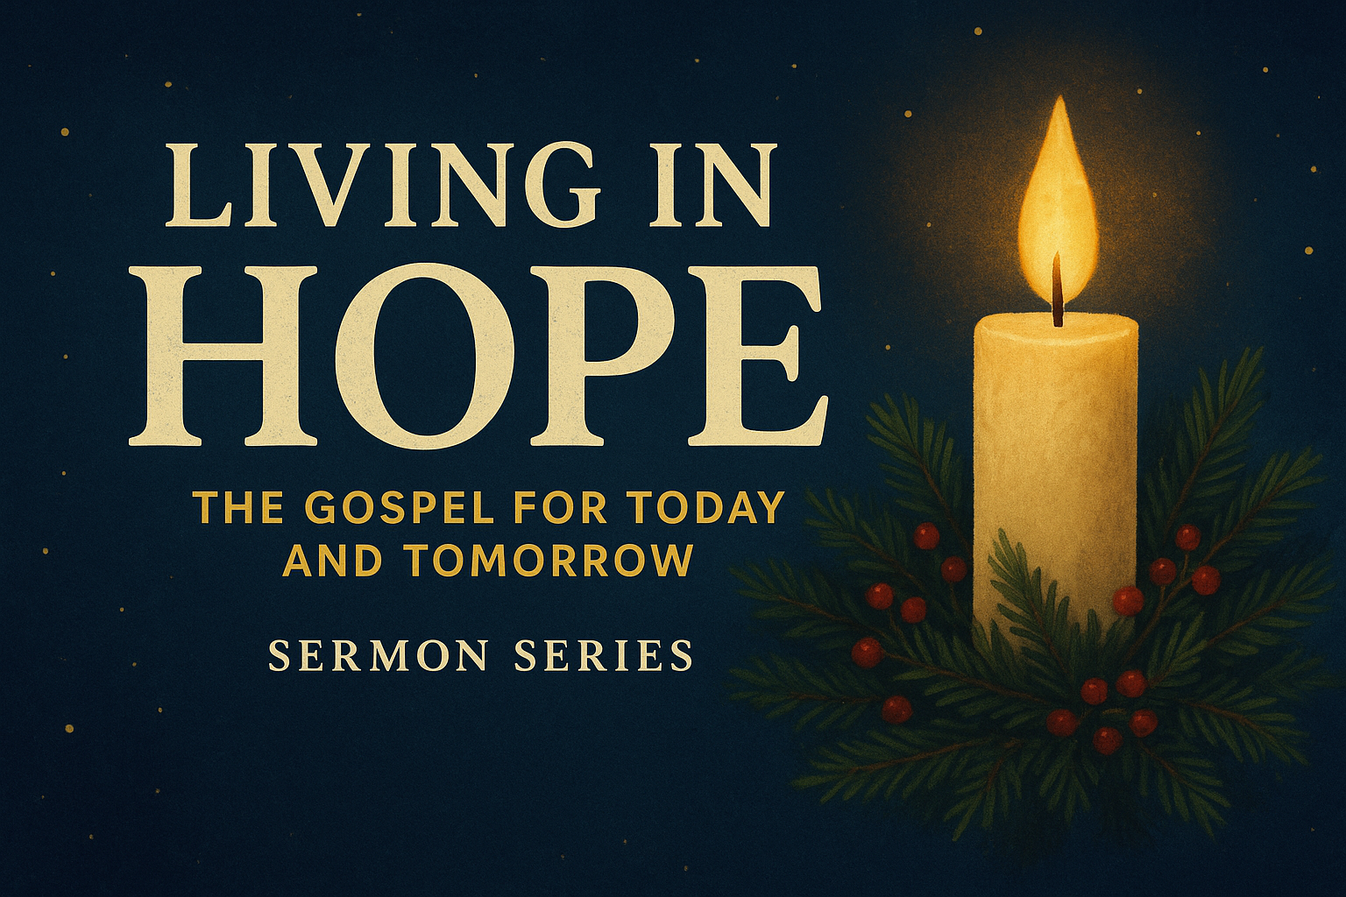

DAILY REFLECTIONS FOR THE SEASON OF ADVENT

Week 1 – The Gospel of Hope: Hope given in Christ
Text: Romans 1:1–7
Main Points
- The Gospel Promised (vv. 1–2)
- The Gospel Fulfilled (vv. 3–4)
- The Gospel Proclaimed (vv. 5–7)
Application
- What are you building your hope on? If it’s not Christ, it won’t last.
- Receive Christ’s call to belong to Him.
- Live as people who carry the good news of hope into a hopeless world.
Daily Readings (Optional Sunday Reading: Romans 1:1-7 Focus: Hope Given in Christ)
Day | Scripture | Reflection or Challenge
Mon | Isaiah 9:2–7 | How does this prophecy point to the hope we have in Christ’s coming?
Tue | Luke 1:26–38 | What does Mary’s response teach us about trusting God’s promises?
Wed | Romans 5:1–5 | How does hope grow through suffering and perseverance?
Thu | 1 Corinthians 15:1–8 | Why is the resurrection essential to our hope?
Fri | 1 Peter 1:3–9 | What difference does “living hope” make in your daily life?
Sat | John 1:1–14 | Where do you see God’s promise fulfilled in the Word made flesh?

Week 2 – The Urgency of Hope: Hope shapes daily holiness
Text: Romans 13:11–14
Main Points
- Wake Up! (v. 11)
- Cast Off Darkness (vv. 12–13)
- Put On Christ (v. 14)
Application
- Where are you tempted to “sleepwalk” spiritually?
- What sins need to be laid aside as clothing of darkness?
- Are you daily putting on Christ through Word, prayer, and sacrament?

Daily Readings (Optional Sunday Reading: Romans 13:11-14 Focus: Hope Shapes Daily Holiness)
Day | Scripture | Reflection or Challenge
Mon | Ephesians 5:8–14 | What does it mean for you to “walk as children of light”?
Tue | Colossians 3:1–10 | What “old clothes” of sin need to be stripped away in your life?
Wed | Matthew 24:42–44 | How can you live each day ready for Christ’s return?
Thu | 1 Thessalonians 5:1–11 | How does hope protect you from spiritual complacency?
Fri | Romans 6:1–11 | How does baptism connect you to new life in Christ?
Sat | Philippians 3:12–16 | What step can you take to “press on” in your faith this week?

Week 3 – The Patience of Hope: Hope sustains us in waiting
Text: James 5:7–11
Main Points
- Waiting with Patience (vv. 7–8)
- Waiting without Grumbling (v. 9)
- Waiting with Endurance (vv. 10–11)
Application
- Where is impatience creeping into your faith?
- How do you handle hardship—grumbling or trusting?
- Can you encourage others by pointing them to God’s mercy and compassion?

Daily Readings (Optional Sunday Reading: James 5:7-11 Focus: Hope Sustains Us in Waiting)
Day | Scripture | Reflection or Challenge
Mon | Psalm 37:1–9 | What does trusting in the Lord look like when you’re weary of waiting?
Tue | Lamentations 3:19–26 | How can you remind yourself of God’s faithfulness each day?
Wed | Romans 8:18–25 | How does hope help you face suffering with endurance?
Thu | Hebrews 10:32–39 | What promises of God give you strength to persevere?
Fri | 1 Thessalonians 1:2–10 | How do faith, love, and hope show up in your life?
Sat | James 1:2–4, 12 | How might God be shaping your character through patient endurance?

Week 4 – The Unity of Hope: Hope unites us in praise
Text: Romans 15:4–13
Main Points
- Hope from Scripture (v. 4)
- Hope in Christ (vv. 5–9)
- Hope Overflowing (vv. 10–13)
Application
- Does your hope in Christ shape how you welcome others?
- Are you encouraging others with Scripture?
- Is your life marked by overflowing joy and peace—or by fear and division?

Daily Readings (Optional Sunday Reading: Romans 15:4-13 Focus: Hope Unites Us in Praise)
Day | Scripture | Reflection or Challenge
Mon | Psalm 133 | How can you help build unity within your church family this week?
Tue | John 17:20–23 | What does Jesus’ prayer for unity mean for your relationships?
Wed | Galatians 3:26–29 | How does hope in Christ erase barriers of division?
Thu | Ephesians 4:1–6 | What does it look like to live “worthy of your calling”?
Fri | Romans 12:9–18 | Which part of Paul’s description of love challenges you most?
Sat | Revelation 7:9–12 | How does this picture of heavenly unity give you hope today?

